- Purpose: Calculate the total quantity of pizzas ordered for each category
SELECT
pt.category AS pizza_category,
SUM(od.quantity) AS total_quantity
FROM
order_details AS od
JOIN
pizzas AS p
ON od.pizza_id = p.pizza_id
JOIN
pizza_types AS pt
ON pt.pizza_type_id = p.pizza_type_id
GROUP BY
pt.category
ORDER BY
total_quantity DESC;

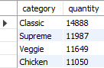

- Purpose: Analyze the distribution of orders by hour of the day
SELECT
HOUR(order_time) AS order_hour,
COUNT(order_id) AS total_orders
FROM
orders
GROUP BY
order_hour
ORDER BY
order_hour;

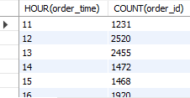

- Purpose: Analyze the distribution of pizza types across different categories
SELECT
category AS pizza_category,
COUNT(name) AS total_pizza_types
FROM
pizza_types
GROUP BY
category
ORDER BY
total_pizza_types DESC;
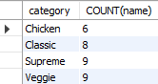

- Purpose: Calculate the average number of pizzas ordered per day
SELECT
ROUND(AVG(daily_quantity), 0) AS avg_pizzas_per_day
FROM (
SELECT
o.order_date,
SUM(od.quantity) AS daily_quantity
FROM
orders AS o
JOIN
order_details AS od
ON o.order_id = od.order_id
GROUP BY
o.order_date
) AS daily_orders;

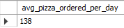

- Purpose: Identify the top 3 most ordered pizza types based on total revenue
SELECT
pt.name AS pizza_name,
ROUND(SUM(od.quantity * p.price), 2) AS total_revenue
FROM
order_details AS od
JOIN
pizzas AS p
ON od.pizza_id = p.pizza_id
JOIN
pizza_types AS pt
ON pt.pizza_type_id = p.pizza_type_id
GROUP BY
pt.name
ORDER BY
total_revenue DESC
LIMIT 3;

